Unit-3
Modules and Packages

Working with Packages and Modules
- Python packages are a way to organize and structure code by grouping related modules into directories.
- A package is essentially a folder that contains an __init__.py file and one or more Python files (modules).
- Allows modules to be easily shared and distributed across different applications.
- How to create and access packages in python
- Create a Directory: Make a directory for your package. This will serve as the root folder.
- Add Modules: Add Python files (modules) to the directory, each representing specific functionality.
- Include __init__.py: Add an __init__.py file (can be empty) to the directory to mark it as a package.
- Add Sub packages (Optional): Create subdirectories with their own __init__.py files for sub packages.
- Import Modules: Use dot notation to import, e.g., from mypackage.module1 import greet.
Eg.
We are creating a Math Operation Package to organize Python code into a structured package for addition and subtraction, multiplication and division. Each operation is implemented in separate modules, allowing for modular, reusable and maintainable code.
math_operations/__init__.py:
from .add import add
from .subtract import subtract

math_operations/add.py:
def add(a, b):
return a + b

math_operations/sub.py:
def subtract(a, b):
return a – b

In the same way we can create the multiply and divide modules. Now, let's take an example of importing the module into a code and using the function:
from math_operations import add, subtract

# Perform basic operations
print("Addition:", add(5, 3))
print("Subtraction:", subtract(10, 4))

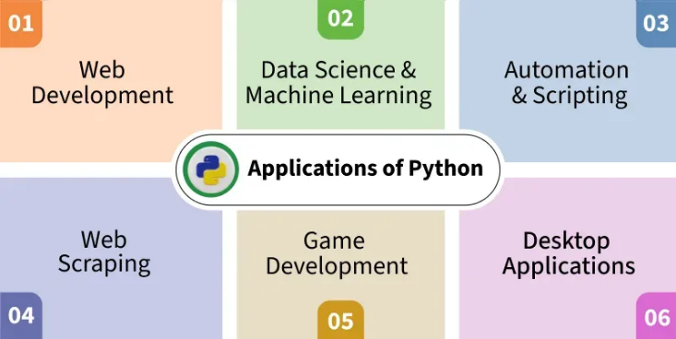 | 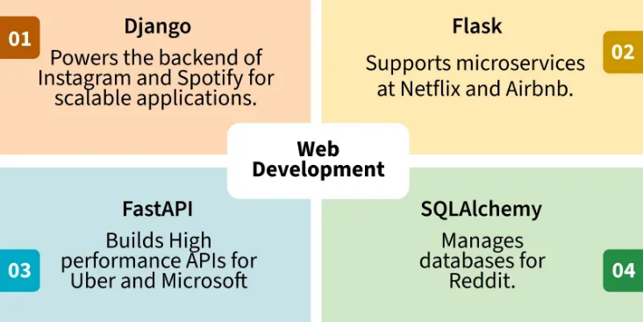
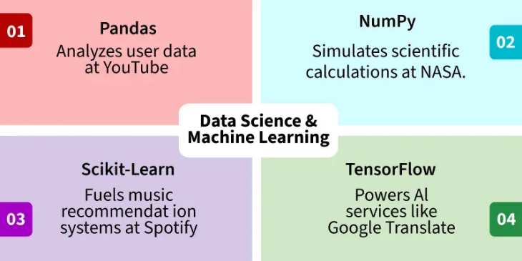 | 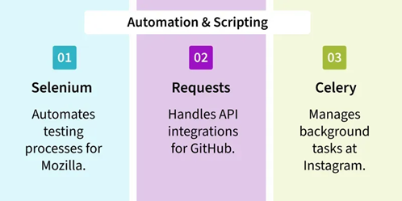
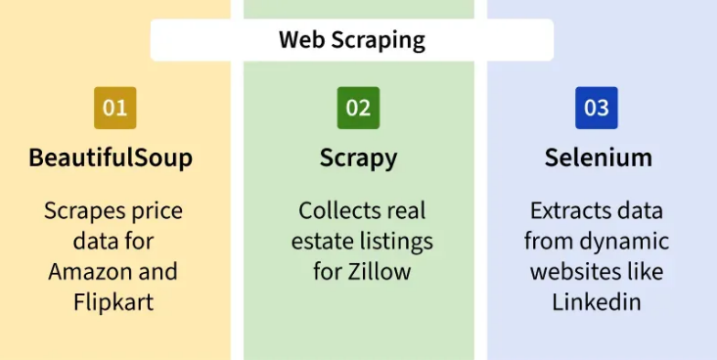 | 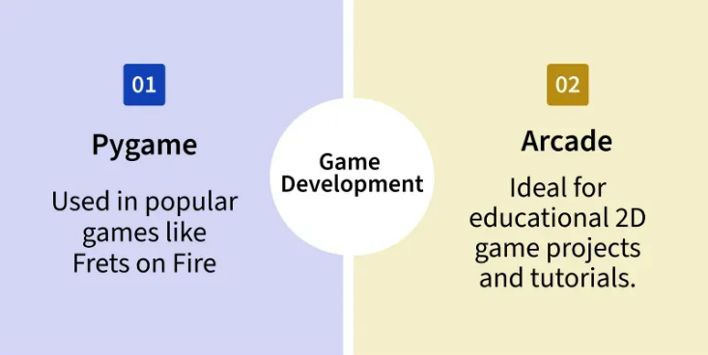
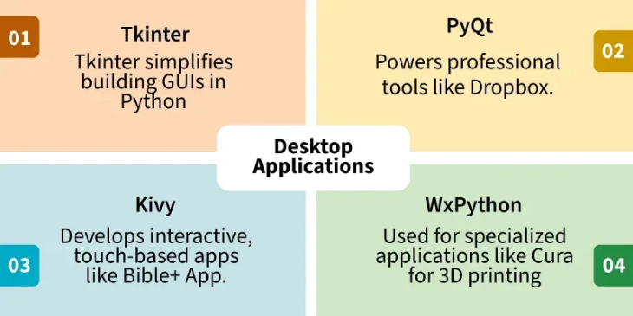

Version Control - GIT
- A Version Control System (VCS) is a tool used in software development and collaborative projects to track and manage changes to source code.
- It allows developers to:
- Record and track every update to the codebase
- Collaborate on code without overwriting each other's work
- Revert to earlier states of the project if needed
- Maintain a detailed and structured history of the project’s evolution
- If something breaks or doesn’t work, the team can compare versions, isolate the issue, and restore stable code without starting from scratch.
- Git is a powerful version control system widely used in software development to track changes, collaborate on projects, and manage code efficiently.
- Basic Concepts
- Repository (Repo)
A repository is a storage space where your project's files and their revision history are kept. It can be local (on your computer) or remote (on a server).
- Commit
A commit represents a snapshot of your repository at a specific point in time. Each commit has a unique SHA-1 hash identifier and includes a message describing the changes.
- Branch
A branch is a parallel version of your repository. It allows you to work on different features or fixes without affecting the main codebase. The default branch in a new repository is usually called master or main.
- Merge
Merging is the process of combining changes from one branch into another. It helps integrate the work done in different branches.
- Clone
Cloning is the process of creating a copy of a remote repository on your local machine.
- Remote
A remote is a common repository that all team members use to exchange their changes.
- Staging Area / Index
The staging area (or index) is where you prepare changes to be committed. It allows you to review and organize changes before making a commit.
- Working Directory
The working directory is where you modify your files. Changes in the working directory are not tracked by Git until you stage them.
- Git commands to push the code files into a Github repo easily:
- git init
Initializes a new Git repository in your project folder.
- git status
Shows changes and files that are not yet tracked.
- git add .
Adds all files to the staging area.
- git commit -m "Initial commit"
Saves your changes with a message.
- git branch -M main
Renames the current branch to main
- git remote add origin https://github.com/username/repo-name.git
Connects your local folder to your GitHub repository.
- git push -u origin main
Pushes your files to GitHub.

Python connectivity with Databases MYSQL
- MySQL is a widely used open-source relational database for managing structured data. Integrating it with Python enables efficient data storage, retrieval and manipulation within applications.
- To work with MySQL in Python, we use MySQL Connector, a driver that enables seamless integration between the two.
- It handles the conversion between Python and MySQL data types and is implemented in pure Python, requiring no third-party dependencies.
- Installation
To install the Python-mysql-connector module, one must have Python and PIP, preinstalled on their system.
pip3 install mysql-connector-python
- Connecting to MySQL Server
We can connect to both local and cloud-based MySQL databases using the connect method of mysql-connector library.
- Creating Database
For this, we will first create a cursor() object and will then pass the SQL command as a string to the execute() method.
- Creating Tables
For creating tables we will follow the similar approach of writing the SQL commands as strings and then passing it to the execute() method of the cursor object.
- Insert Data into Tables
To insert data into the MySQL table Insert into query is used.
- Inserting Multiple Rows
To insert multiple values at once, executemany() method is used. This method iterates through the sequence of parameters, passing the current parameter to the execute method.
- Fetching Data
We can use the select query on the MySQL tables.
- Update Data
The update query is used to change the existing values in a database.
- Delete Data from Table
We can use the Delete query to delete data from the table in MySQL.
Eg.
import mysql.connector

db = mysql.connector.connect(
host = "",
user = "",
password = "",
database = "",
port = 5051
)

cursor = db.cursor()

cursor.execute("CREATE TABLE IF NOT EXISTS STUDENT (id INT AUTO_INCREMENT PRIMARY KEY, name VARCHAR(50), age INT);")

#create
cursor.execute('INSERT INTO STUDENT VALUES (1, "abc", 26);')
cursor.execute('INSERT INTO STUDENT VALUES (2, "xyz", 25);')
cursor.execute('INSERT INTO STUDENT VALUES (3, "pqr", 24);')

#read
cursor.execute("SELECT * FROM STUDENT;")
rows = cursor.fetchall()
print(rows)

#update
cursor.execute('UPDATE STUDENT SET age = 27 WHERE name = "abc"')
db.commit()

#delete
cursor.execute('DELETE FROM STUDENT where name = "abc"')
db.commit()

cursor.close()
db.close()

